**Deliverable 3: System Modelling and Architectural Design**

**Food Wastage Application: The Sustainable Spoonful**

**By**

**Lea Thumbiran, Lucinda Zachos, Melany Opperman, Santana Bradbury**

A Mini-Dissertation Submitted as a Partial Requirement for the Bachelor Science in Information Technology: Mobile Application and Web Services

In the Faculty of Information Technology, Eduvos

**Supervisor:**

Mr. Ian Masaga

Date: 15 May 2023

1. **Student Details**

|  |  |  |  |
| --- | --- | --- | --- |
| Student Details | Student Number | Telephone Number | Email Address |
| Bradbury, Santana | CNZJB3199 | 071 864 4170 | cnzjb3199@vossie.net |
| Opperman, Melany | 6P6NPJX46 | 074 709 6778 | 6p6npjx46@vossie.net |
| Thumbiran, Lea | LMTPQFTH6 | 079 898 2004 | lmtpqfth6@vossie.net |
| Zachos, Lucinda | Y34VR5C17 | 071 878 3138 | Y34vr5c17@vossie.net |

1. **Supervisor Details**

|  |  |  |
| --- | --- | --- |
| Supervisor Name | Faculty | Email Address |
| Ian, Masaga | IT | ian.masaga@eduvos.com |

**Deliverable 3: Table of Contents**

Chapter 3: System Modelling and Architectural Design 8

3.1. Introduction 8

3.2. Presentation Layer 8

3.2.1. User Experience considerations 8

3.2.1.1. Fact-Finding Techniques 9

3.2.1.2. Analysis of User Requirements 10

3.2.1.3 Tools and Diagrams used 12

User Flow Diagram: 13

3.2.2. User Interface Design 13

3.2.2.1 Designs 13

Wireframe Designs: 13

3.2.2.2 Design Tools and Techniques 23

3.2.2.3 Designs Look and Feel (Aesthetic, Business Colours, etc.) 24

Design Iteration 1: 25

3.2.2.4 Iterative and Incremental Design 35

Design Iteration 2: 35

3.3. Business Layer 46

3.3.1. Operation/Process Models Design 46

Use-Case Diagram – Iteration 1: 46

Use-Case Diagram – Iteration 2: 47

Sequence Diagram – Iteration 1: 49

Sequence Diagram – Iteration 2: 50

3.3.2. Data Handling Operation Design 51

3.3.3. Diagrams 54

Functional Decomposition Diagram – iteration 1 54

Functional Decomposition Diagram – iteration 2 55

3.3.4. Iterative and Incremental Design 56

3.4. Data Layer 56

3.4.1 Logical Data Models 56

3.4.2 Diagrams, Tools, and Techniques 59

Context Diagram – Iteration 1: 60

Context Diagram – Iteration 2: 61

Entity Relationship Diagram – Iteration 1: 62

Entity Relationship Diagram – Iteration 2: 62

Data Flow Diagram – Iteration 1: 63

Data Flow Diagram – Iteration 2: 64

3.4.3 Iterative and Incremental Design 65

3.5. Conclusion 65

Bibliography 66

**Deliverable 3: Table of Figures**

Figure 1: Ages of Respondents. 10

Figure 2: Determining whether finding healthy and affordable food was difficult. 11

Figure 3: Determining whether food-saver applications have been used before. 11

Figure 4- User Flow Diagram for The Sustainable Spoonful System (Cabrera, 2022). 13

Figure 5 - Landing Page when the user opens the application for the first time. 14

Figure 6 - Registration Page so that users can create an account. 14

Figure 7 - Login Page so that users can login using the account they have just created. 15

Figure 8 - Forgot Password page for when a user wishes to reset their password. 15

Figure 9 - Confirmation screen that shows that a password reset email was sent to the user. 16

Figure 10 - Home Page for the Sustainable Spoonful Mobile Application. 16

Figure 11 - Discounted Products Page for users to search for discounted products based on the store and location. 17

Figure 12 - Discounts listed for a specific store. 17

Figure 13 - QR code for the selected discounted product that users can scan at the store to collect their item. 18

Figure 14 - Account Page for a user to manage their account. 18

Figure 15 - Prompting the user to log in first before they can edit their account details. 19

Figure 16 - User logging in. 19

Figure 17 - Edit Account Page. 20

Figure 18 - Confirmation that the user has updated their account details. 20

Figure 19 - Prompting the user to login before they delete their account. 21

Figure 20 - Logging in. 21

Figure 21 - Delete Account Page. 22

Figure 22 - Confirmation that the user has deleted their account. 22

Figure 23 - Prompting the user to log out of their account or go back. 23

Figure 24 - Confirmation that the user has logged out of their account. 23

Figure 25 - Colour Palette for The Sustainable Spoonful. 24

Figure 26 - Logo for The Sustainable Spoonful. 25

Figure 27 - Landing Page when the user opens the application for the first time. 25

Figure 28 - Registration Page so that users can create an account. 26

Figure 29 - Login Page so that users can login using the account they have just created. 26

Figure 30 - Forgot Password page for when a user wishes to reset their password. 27

Figure 31 - Confirmation screen that shows that a password reset email was sent to the user. 27

Figure 32 - Home Page for the Sustainable Spoonful Mobile Application. 28

Figure 33 - Discounted Products Page for users to search for discounted products based on the store and location. 28

Figure 34 - Discounts listed for a specific store. 29

Figure 35 - QR code for the selected discounted product that users can scan at the store to collect their item. 29

Figure 36 - Account Page for a user to manage their account. 30

Figure 37 - Prompting the user to log in first before they can edit their account details. 30

Figure 38 - User logging in. 31

Figure 39 - Edit Account Page. 31

Figure 40 - Confirmation that the user has updated their account details. 32

Figure 41 - Prompting the user to login before they delete their account. 32

Figure 42 - Logging in. 33

Figure 43 - Delete Account Page. 33

Figure 44 - Confirmation that the user has deleted their account. 34

Figure 45 - Prompting the user to log out of their account or go back. 34

Figure 46 - Confirmation that the user has logged out of their account. 35

Figure 47 - Landing Page when the user opens the application for the first time. 36

Figure 48 - Registration Page so that users can create an account. 36

Figure 49 - Login Page so that users can login using the account they have just created. 37

Figure 50 - Forgot Password page for when a user wishes to reset their password. 37

Figure 51 - Confirmation screen that shows that a password reset email was sent to the user. 38

Figure 52 - Home Page for the Sustainable Spoonful Mobile Application. 38

Figure 53 - Discounted Products Page for users to search for discounted products based on the store and location. 39

Figure 54 - Discounts listed for a specific store. 39

Figure 55 - QR code for the selected discounted product that users can scan at the store to collect their item. 40

Figure 56 - Account Page for a user to manage their account. 40

Figure 57 - Prompting the user to log in first before they can edit their account details. 41

Figure 58 - User logging in. 41

Figure 59 - Edit Account Page. 42

Figure 60 - Confirmation that the user has updated their account details. 42

Figure 61 - Prompting the user to login before they delete their account. 43

Figure 62 - Logging in. 43

Figure 63 - Delete Account Page. 44

Figure 64 - Confirmation that the user has deleted their account. 44

Figure 65 - Prompting the user to log out of their account or go back. 45

Figure 66 - Confirmation that the user has logged out of their account. 45

Figure 67 - Use Case Diagram – Iteration 1 for The Sustainable Spoonful System (Tilley & Rosenblatt, 2017). 46

Figure 68 - Use Case Diagram – Iteration 2 for The Sustainable Spoonful System (Tilley & Rosenblatt, 2017). 48

Figure 69 - Sequence Diagram – Iteration 1 for The Sustainable Spoonful System (Lucidchart, 2022). 49

Figure 70 - Sequence Diagram – Iteration 2 for The Sustainable Spoonful System (Lucidchart, 2022). 50

Figure 71 - Functional Decomposition Diagram - Iteration 1 for The Sustainable Spoonful System (Tilley & Rosenblatt, 2017). 54

Figure 72 - Functional Decomposition Diagram - Iteration 2 for The Sustainable Spoonful System (Tilley & Rosenblatt, 2017). 55

Figure 73 - Context Diagram - Iteration 1 for The Sustainable Spoonful System (Pedriquez, 2022). 60

Figure 74 - Context Diagram - Iteration 2 for The Sustainable Spoonful System (Pedriquez, 2022) 61

Figure 75 - Entity Relationship Diagram - Iteration 1 for The Sustainable Spoonful System (Brumm, 2022). 62

Figure 76 - Entity Relationship Diagram - Iteration 2 for The Sustainable Spoonful System (Brumm, 2022). 62

Figure 77 - Data Flow Diagram - Iteration 1 for The Sustainable Spoonful System (Lucidchart, 2023). 63

Figure 78 - Data Flow Diagram - Iteration 2 for The Sustainable Spoonful System (Lucidchart, 2023). 64

# Chapter 3: System Modelling and Architectural Design

## 3.1. Introduction

When approaching the design aspect of The Sustainable Spoonful mobile application, we needed to consider the user experience and user interface design as well as the architectural design and systems design.

The following sections cover how we plan to approach the UX (User Experience) and UI (User Interface) design as well as the system modelling and architectural design during the development of this mobile application and outline the structure in which we have tried to ensure user satisfaction and maximize the mobile applications usability.

This will be done using iterative and incremental design processes by way of mapping out our initial plans for the application, gathering requirements, analysis, and design, testing, and finally evaluating and then further breaking each section down further into more manageable sections building and improving on the previous versions (Wrike.com, 2023).

Lastly, with the use of iterative design, it enables flexibility, adaptability, and the ability to address any changes that need to be made to this project.

## 3.2. Presentation Layer

## 3.2.1. User Experience considerations

**The factors that must be considered to enhance the users’ experience are as follows:**

* **Navigation:** How experienced is the user when it comes to using desktop and mobile applications (Whitten & Bentley, 2007)? Can the user be deemed as an expert user or a novice user (Whitten & Bentley, 2007)? This can affect the overall feel of the mobile application as the language used, success messages, warning messages and error messages differs between an expert user and a novice user (Whitten & Bentley, 2007). In this case, the users of this food-saver mobile application will most likely be novice users. Extra care must be taken to ensure that they are provided with clear and concise instructions to navigate through the mobile application. Users must be able to easily and seamlessly navigate between the different features of the mobile application. Error messages (such as an account or product not being found) and warning messages (such as an incorrect password being entered) must be handled and written in such a way that the user understands what actions to take. These messages can help users to prevent an unwanted or irreversible action (such as deletion of their account) from occurring (Whitten & Bentley, 2007).
* **System Compatibility:** What operating system will the mobile application support (Whitten & Bentley, 2007)? Will it run on Android or iOS, or perhaps on both? This food-saver mobile application will be provided to users using the Android operating system and will run on devices running at minimum Android 5. Which display resolutions will the mobile application support (Whitten & Bentley, 2007)? At this current point in time the mobile application will not target specific display resolutions. However, the mobile application will adapt based on the users’ device.
* **Visual appeal:** The mobile application must be visually appealing. Appropriate colours, icons and language must be used to enhance the users’ experience.
* **Feedback and support:** There must be options for the user to provide feedback and request for support. For this mobile application there will be options for the user to provide feedback and request for support in the form of a ticket.

## 3.2.1.1. Fact-Finding Techniques

The fact-finding techniques used were observation, research, and questionnaires (Tilley & Rosenblatt, 2017). Observation provided the development team with first-hand experience about how businesses and restaurants operate in South Africa. It enabled the team to understand the current practices, challenges faced and potential areas for improvement when it comes to the issue of food wastage. Conducting research provided the development team with a broader understanding of the impact of food wastage on the economy, its people, and the environment. The research assisted the team in identifying the significance of the problem and the implications it has for South Africa. Researching is a valuable fact-finding technique to gather existing knowledge and data that can be used to inform the design and development process (Tilley & Rosenblatt, 2017). Questionnaires were used to gather specific information from the people of South Africa regarding how they perceived food wastage and whether they experienced it first-hand. The semi-structured questionnaires enabled the team to gather data on how people were currently dealing with the issue of food wastage and what their expectations for addressing it in the future were. Questionnaires are an important fact-finding technique used to gather valuable information from a wider audience (Tilley & Rosenblatt, 2017).

## 3.2.1.2. Analysis of User Requirements

**The facts gathered were as follows:**

During observation, it was found that restaurants and businesses throw out food products that were close to the end of their shelf-life, were not sold at the end of the day or were bought in excess. This led to a loss in profit. As a result, businesses and restaurants must increase the prices of their food products to cover their losses. Businesses and restaurants need a system where they can sell the food products to customers at a discounted price or donate the products to a local charity if it is not collected at the end of the day.

During research, it was found that about 1/3rd of all food in South Africa is wasted and thrown out. It was also found that farms would throw out crops that they deemed were not fit for sale. It has negatively affected the economy and led to the inflation of food prices. The agricultural sector needs a system where they can sell their produce at a reduced price to consumers instead of throwing it out.

After summarising the results from the questionnaires, the most common responses found were:

* 65.8% of respondents were between the ages of 18 to 30. This is seen in the diagram below:

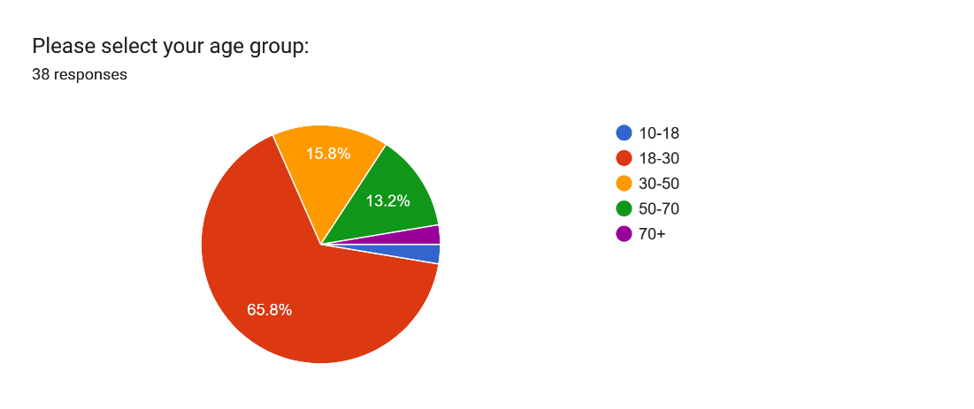

Figure 1: Ages of Respondents.

* 76.3% of respondents found that it was difficult to buy healthy food at an affordable price. This is seen in the diagram below:

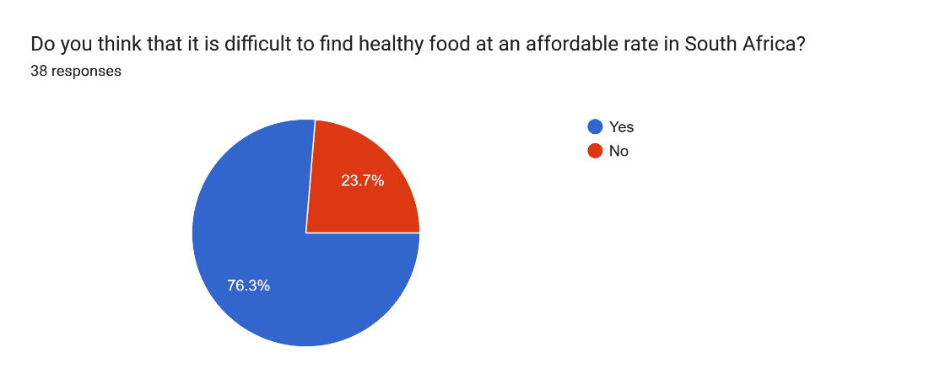

Figure 2: Determining whether finding healthy and affordable food was difficult.

* The reasons why it was difficult to find healthy and affordable food were:
  + Unhealthy food is sold at a lower price than healthy food. This could be due to unhealthy food containing preservatives and extra ingredients to prolong its shelf-life as well as having an overall lower cost compared to its healthier counterparts.
  + The cost of transporting healthy food while ensuring that the food remained fresh and presentable to the consumer further increased its cost when it reached store shelves.
* The most common methods used to cut down on food costs were:
  + Purchasing food products when it was on special.
  + Buying food products in bulk, repackaging them, and freezing them. The food will then only be consumed when it is needed.
  + 97.4% of respondents have not used any food-saver applications. This is seen in the diagram below:

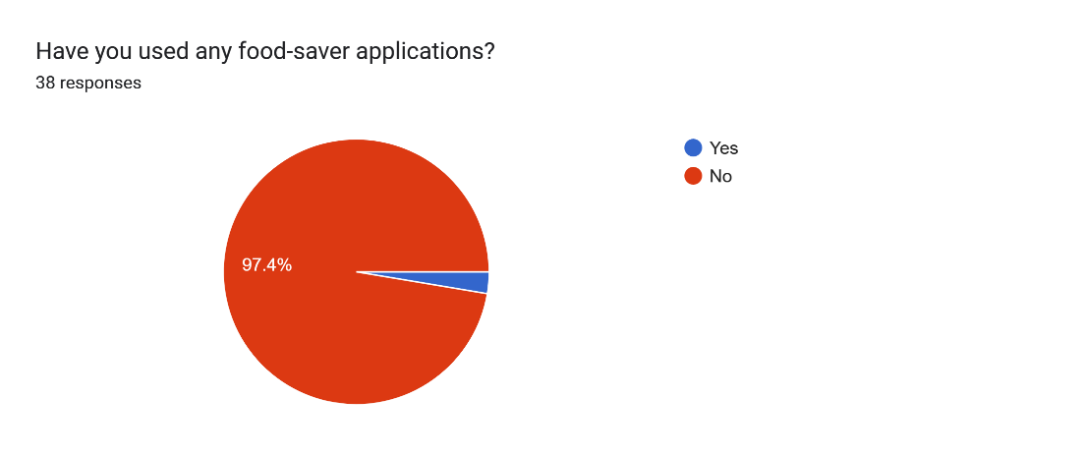

Figure 3: Determining whether food-saver applications have been used before.

* All respondents expressed that they want a food-saver application to be developed.
* Respondents wish that the mobile application:
* Shows restaurants, stores and farms that are offering discounts on their food products.
* Has in person orders that lets customers scan a QR code in a physical store and then collect their items.
* Uses simple and easy to understand language.
* Enables customers to pay for their orders in cash and does not request their card information.
* Donates food products that were not sold at the end of the day to the less fortunate.

**The user requirements have been taken into consideration and have been summarised based on their level of priority below:**

* Display food products that are near the end of their shelf life at a discounted price.
* Search for restaurants/stores that are offering products at a discounted price.
* Search for specific products that are at a discounted price.
* Place an order and receive a QR code to scan at the store.
* Pay for the order in cash.
* Donate products that have not been sold at the end of the day to the less fortunate.

## 3.2.1.3 Tools and Diagrams used

There are many tools used for creating diagrams, these tools include Draw.io, Microsoft Visio and Lucidchart.

For this project Draw.io has been used to create most of the diagrams.

Draw.io is a free-to-use web-based tool that enables designers to create and edit various types of diagrams, such as use-case diagrams, dataflow diagrams, sequence diagrams and context diagrams among others (draw.io, 2023).

A user flow diagram can be used to illustrate the login and register process for this mobile application.

The user flow diagram is shown below:

### User Flow Diagram:

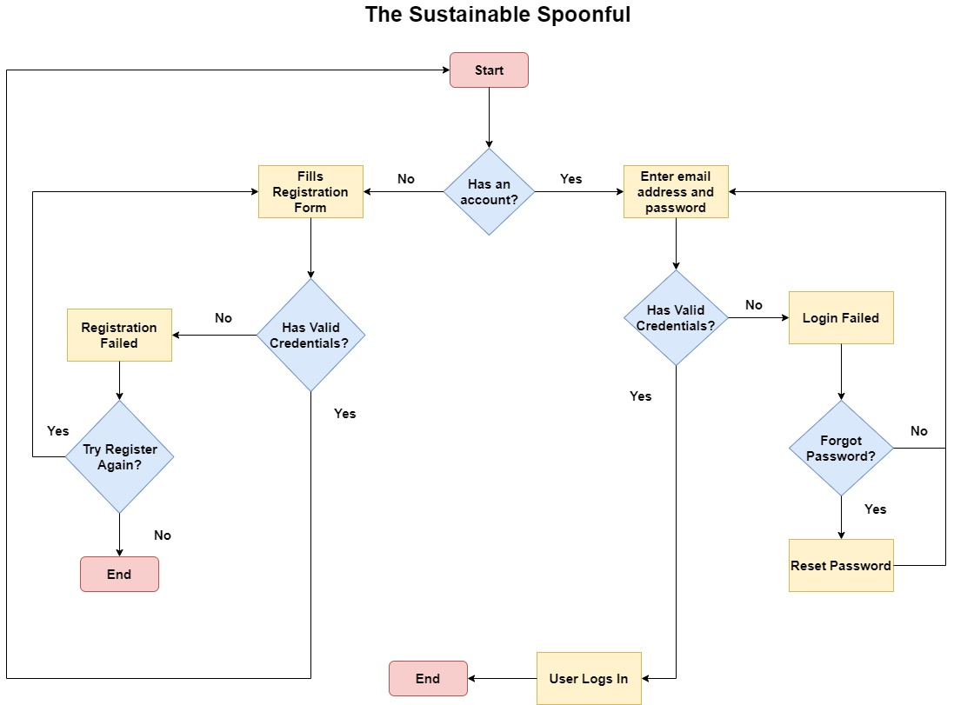

Figure 4- User Flow Diagram for The Sustainable Spoonful System (Cabrera, 2022).

## 3.2.2. User Interface Design

## 3.2.2.1 Designs

### Wireframe Designs:

A link to the wireframe designs can be found here (designshack,2023): [Wireframe Designs](https://www.figma.com/proto/gftl8WufelMBSRWUiJc7YZ/The-Sustainable-Spoonful?type=design&node-id=132-2047&scaling=min-zoom&page-id=132%3A2047)

Figure 5 - Landing Page when the user opens the application for the first time.

Figure 6 - Registration Page so that users can create an account.

Figure 7 - Login Page so that users can login using the account they have just created.

Figure 8 - Forgot Password page for when a user wishes to reset their password.

Figure 9 - Confirmation screen that shows that a password reset email was sent to the user.

Figure 10 - Home Page for the Sustainable Spoonful Mobile Application.

Figure 11 - Discounted Products Page for users to search for discounted products based on the store and location.

Figure 12 - Discounts listed for a specific store.

Figure 13 - QR code for the selected discounted product that users can scan at the store to collect their item.

Figure 14 - Account Page for a user to manage their account.

Figure 15 - Prompting the user to log in first before they can edit their account details.

Figure 16 - User logging in.

Figure 17 - Edit Account Page.

Figure 18 - Confirmation that the user has updated their account details.

Figure 19 - Prompting the user to login before they delete their account.

Figure 20 - Logging in.

Figure 21 - Delete Account Page.

Figure 22 - Confirmation that the user has deleted their account.

Figure 23 - Prompting the user to log out of their account or go back.

Figure 24 - Confirmation that the user has logged out of their account.

## 3.2.2.2 Design Tools and Techniques

Figma has been used to create the prototype and initial designs for this mobile application.

Figma is a free-to-use cloud-based editor that enables system designers to create wireframes, mock-ups as well as user interfaces for their websites and applications (Figma, 2023). It also can create design teams that enable multiple people to work on a design at the same time (Figma, 2023). Designers in a team can add comments and suggestions to specific areas of the design (Figma, 2023). Animations can be made, such as having a drop-down menu that can change colours (Figma, 2023).

Figma was chosen as the most preferred design tool for the reasons above.

In addition to this, the following design techniques were taken into consideration (Whitten & Bentley, 2007):

* All the fields present in the forms (such as the registration and login forms) in this mobile application have labels.
* Every output has a title and provides additional information underneath to guide the user as to what actions to take next.
* Headings are aligned on each page where possible.
* Simple and easy to understand language is used.

## 3.2.2.3 Designs Look and Feel (Aesthetic, Business Colours, etc.)

The following colour palette was used for this mobile application:

Figure 25 - Colour Palette for The Sustainable Spoonful.

The following image is used as the logo for The Sustainable Spoonful mobile application:

Figure 26 - Logo for The Sustainable Spoonful.

### Design Iteration 1:

The link to the first prototype can be found here: [Design 1](https://www.figma.com/proto/gftl8WufelMBSRWUiJc7YZ/The-Sustainable-Spoonful?type=design&node-id=3-3&scaling=scale-down&page-id=0%3A1&starting-point-node-id=3%3A3)

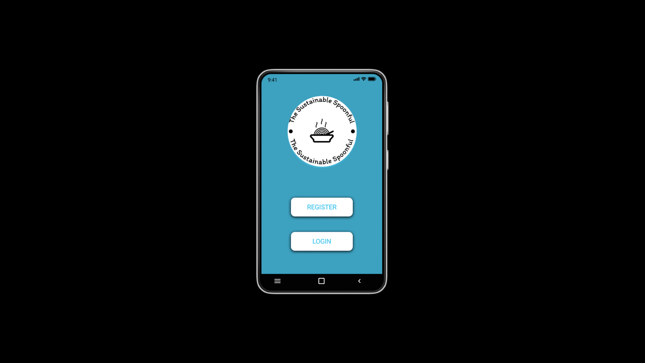

Figure 27 - Landing Page when the user opens the application for the first time.

Figure 28 - Registration Page so that users can create an account.

Figure 29 - Login Page so that users can login using the account they have just created.

Figure 30 - Forgot Password page for when a user wishes to reset their password.

Figure 31 - Confirmation screen that shows that a password reset email was sent to the user.

Figure 32 - Home Page for the Sustainable Spoonful Mobile Application.

Figure 33 - Discounted Products Page for users to search for discounted products based on the store and location.

Figure 34 - Discounts listed for a specific store.

Figure 35 - QR code for the selected discounted product that users can scan at the store to collect their item.

Figure 36 - Account Page for a user to manage their account.

Figure 37 - Prompting the user to log in first before they can edit their account details.

Figure 38 - User logging in.

Figure 39 - Edit Account Page.

Figure 40 - Confirmation that the user has updated their account details.

Figure 41 - Prompting the user to login before they delete their account.

Figure 42 - Logging in.

Figure 43 - Delete Account Page.

Figure 44 - Confirmation that the user has deleted their account.

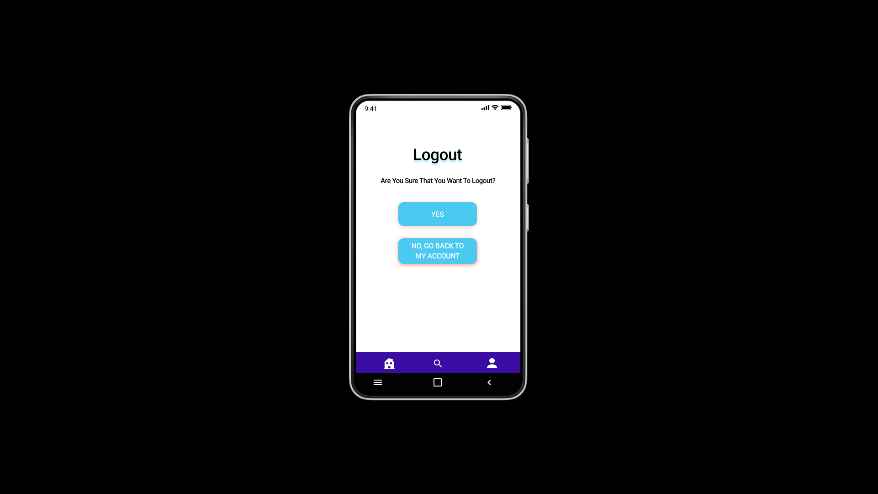

Figure 45 - Prompting the user to log out of their account or go back.

Figure 46 - Confirmation that the user has logged out of their account.

## 3.2.2.4 Iterative and Incremental Design

### Design Iteration 2:

After receiving feedback from users, the design has been adjusted accordingly.

The following changes were made:

* We have added clear and concise error messages to our user interface so that the user will be guided as to what actions to take next when they are navigating through the mobile application.
* We have added more screens in our mobile application, these screens are meant to guide the user and provide the user with a user-friendly experience.
* We have adjusted our colour palette so that it provides a more pleasant user experience.

The link to the second prototype can be found here: [Design 2](https://www.figma.com/proto/gftl8WufelMBSRWUiJc7YZ/The-Sustainable-Spoonful?type=design&node-id=143-4585&scaling=min-zoom&page-id=132%3A855&starting-point-node-id=143%3A4585)

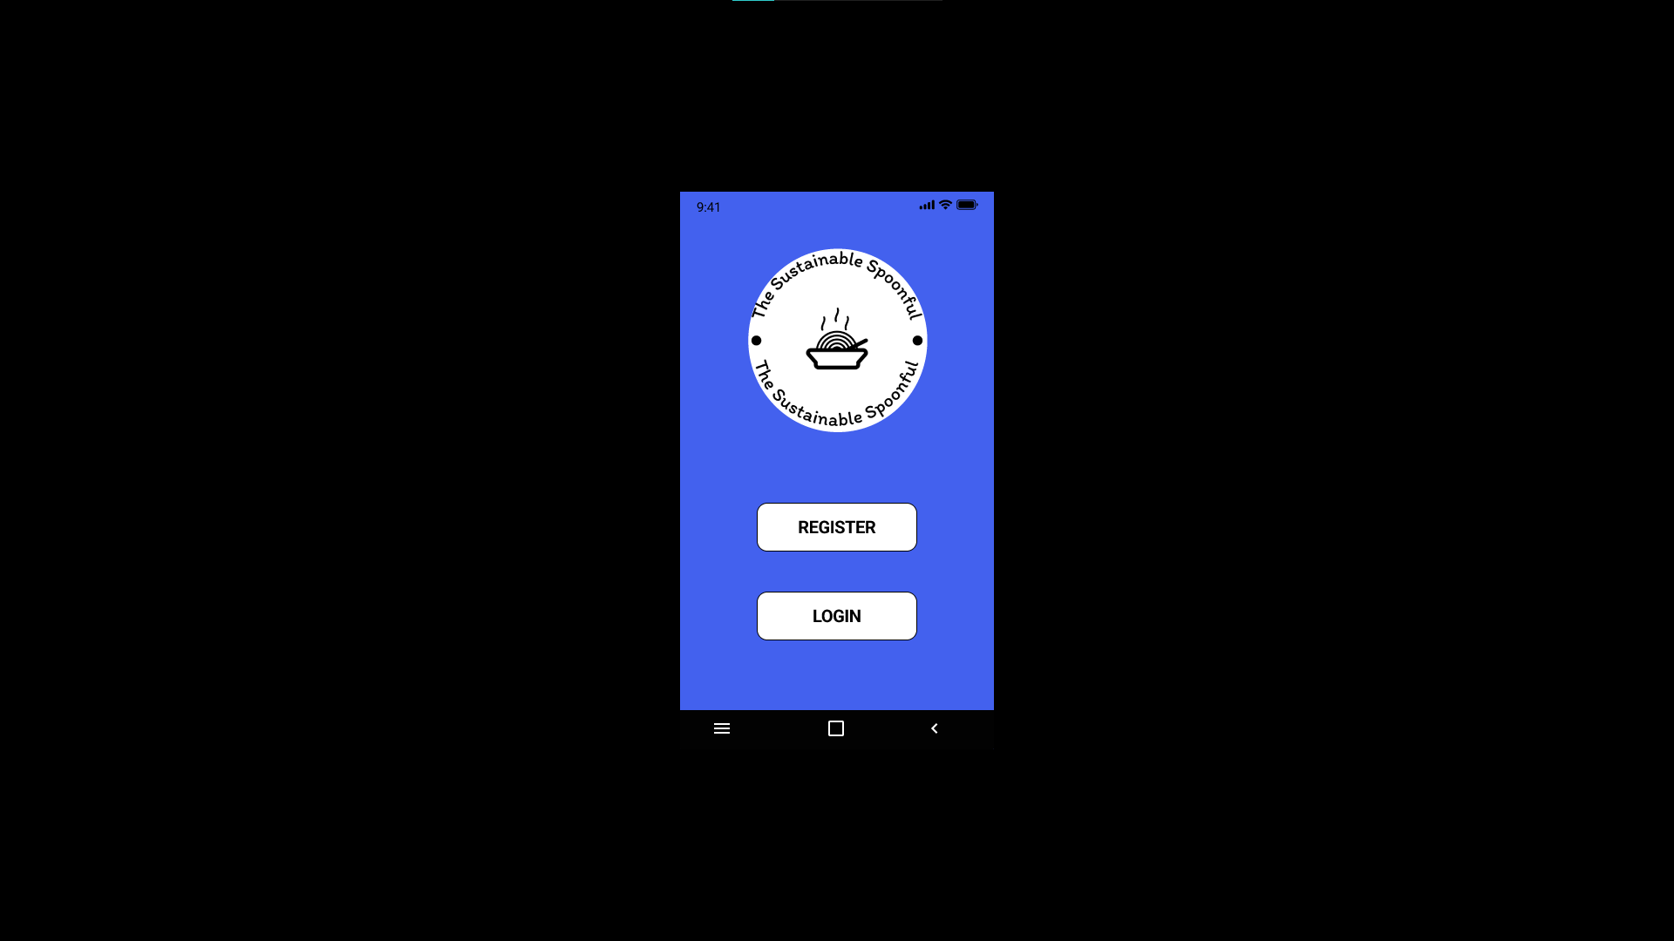

Figure 47 - Landing Page when the user opens the application for the first time.

Figure 48 - Registration Page so that users can create an account.

Figure 49 - Login Page so that users can login using the account they have just created.

Figure 50 - Forgot Password page for when a user wishes to reset their password.

Figure 51 - Confirmation screen that shows that a password reset email was sent to the user.

Figure 52 - Home Page for the Sustainable Spoonful Mobile Application.

Figure 53 - Discounted Products Page for users to search for discounted products based on the store and location.

Figure 54 - Discounts listed for a specific store.

Figure 55 - QR code for the selected discounted product that users can scan at the store to collect their item.

Figure 56 - Account Page for a user to manage their account.

Figure 57 - Prompting the user to log in first before they can edit their account details.

Figure 58 - User logging in.

Figure 59 - Edit Account Page.

Figure 60 - Confirmation that the user has updated their account details.

Figure 61 - Prompting the user to login before they delete their account.

Figure 62 - Logging in.

Figure 63 - Delete Account Page.

Figure 64 - Confirmation that the user has deleted their account.

Figure 65 - Prompting the user to log out of their account or go back.

Figure 66 - Confirmation that the user has logged out of their account.

## 3.3. Business Layer

## 3.3.1. Operation/Process Models Design

### Use-Case Diagram – Iteration 1:

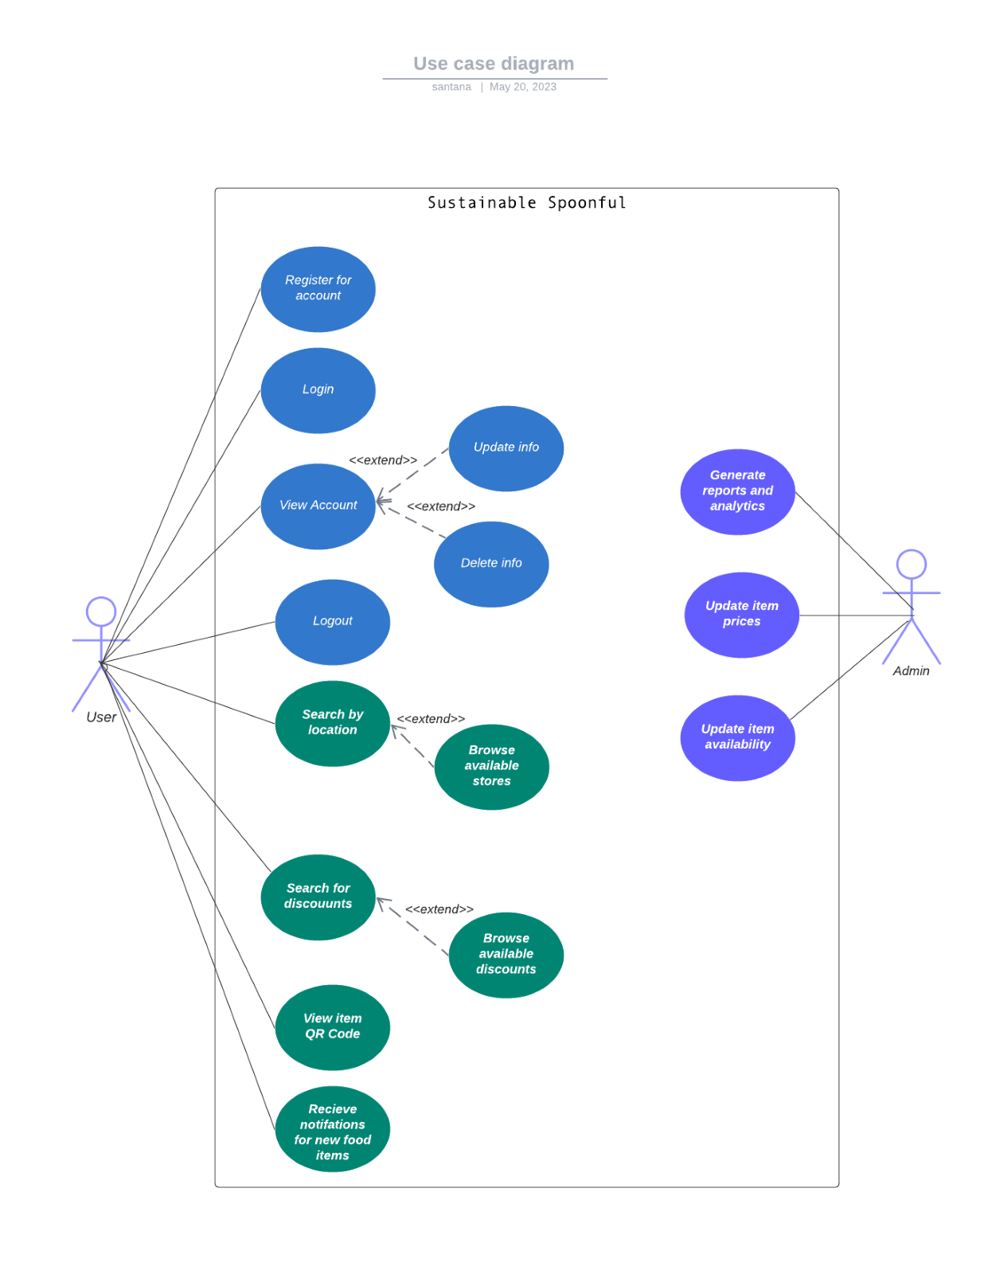

Figure 67 - Use Case Diagram – Iteration 1 for The Sustainable Spoonful System (Tilley & Rosenblatt, 2017).

### Use-Case Diagram – Iteration 2:

**The actors and their use-cases have been identified below:**

**Administrator:**

* Login (includes Authentication)
* Manages Stores (includes Adds Store Name, Adds Store Location and Adds Store Products)
* Manages Products (includes Adds Products, Edits Products, Deletes Products and Sets Products as Donated)
* Receives Feedback
* Logout

**Users:**

* Login (includes Authentication)
* Manages Account (includes View Account, Edit Account Details and Delete Account)
* Searches For Products (includes Searches by Store and Searches by Location)
* Places an Order (includes Receives a QR code)
* Sends Feedback
* Logout

**Guest User:**

* Create Account (includes Add Account Details)

The use-case diagram is shown below:

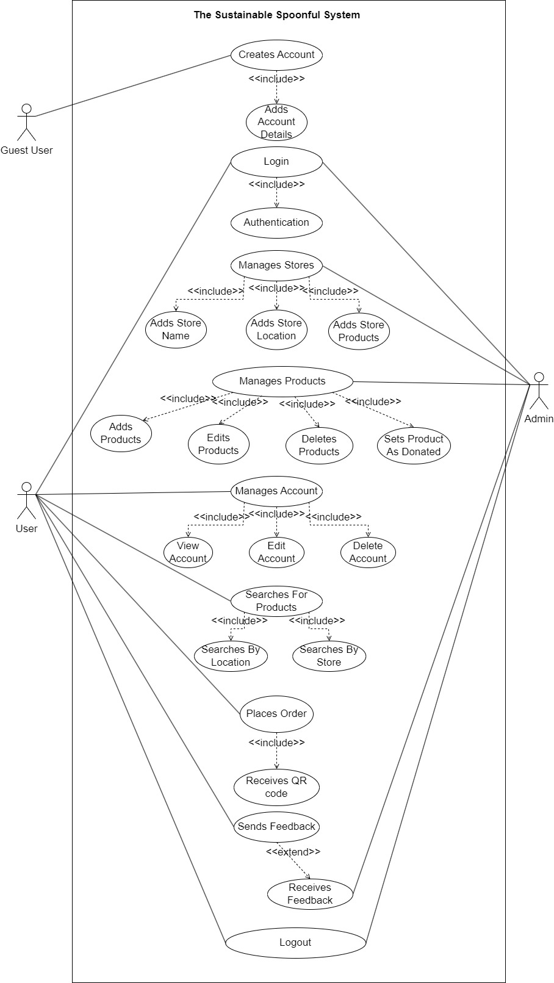

Figure 68 - Use Case Diagram – Iteration 2 for The Sustainable Spoonful System (Tilley & Rosenblatt, 2017).

### Sequence Diagram – Iteration 1:

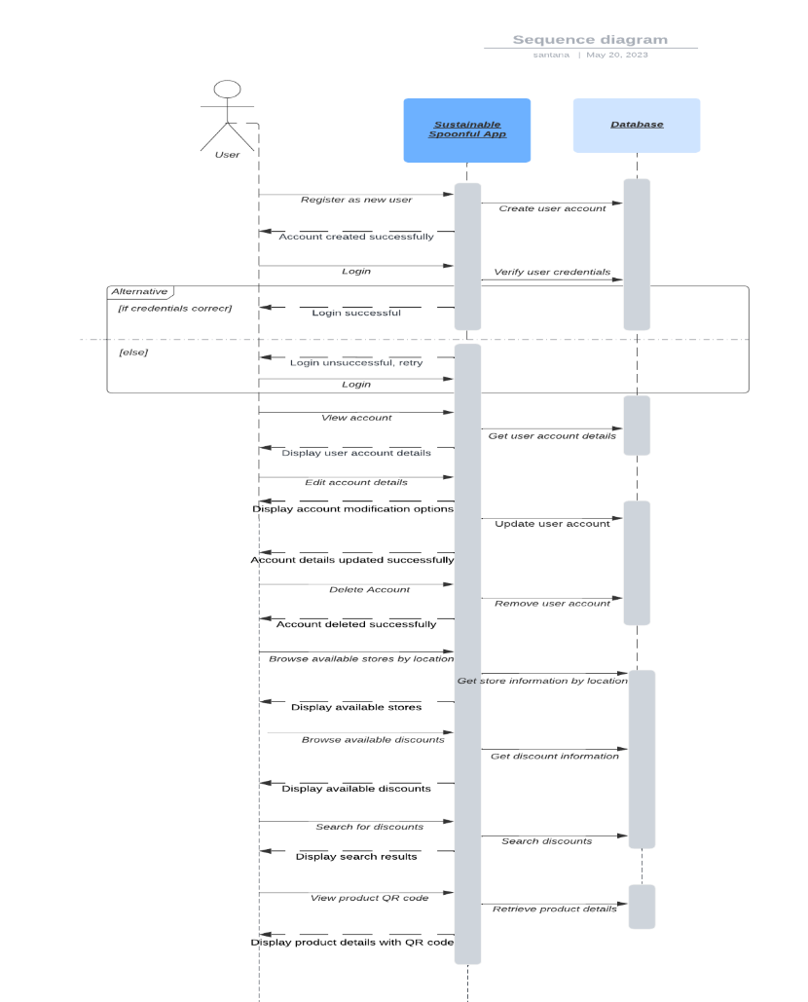

Figure 69 - Sequence Diagram – Iteration 1 for The Sustainable Spoonful System (Lucidchart, 2022).

### Sequence Diagram – Iteration 2:

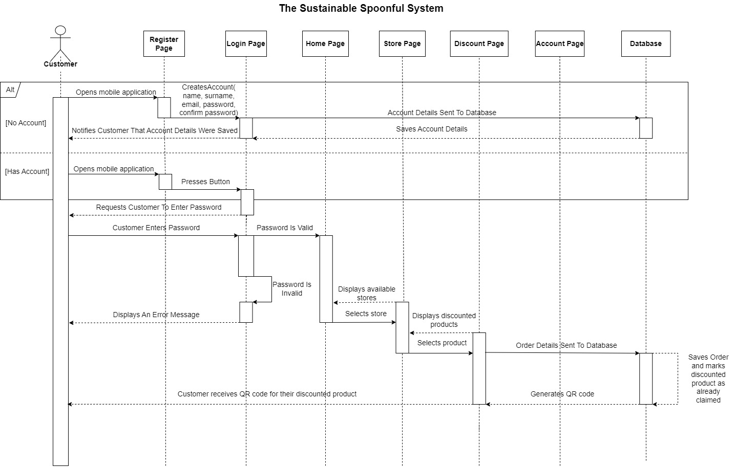

Figure 70 - Sequence Diagram – Iteration 2 for The Sustainable Spoonful System (Lucidchart, 2022).

The sequence diagram will help illustrate the interactions between the user and The Sustainable Spoonful mobile application, as well as the interactions between the mobile application and the database. It shows the flow of actions and information within the application’s operations and process flow (Athuraliya, 2022).

Explanation of the sequence diagram:

1. **User Registration:**

* If the user does not have an account:
  + The customer opens the mobile application and enters their details in the registration page.
  + These details include:
    - Name
    - Surname
    - Email address
    - Password
    - Confirm Password
  + Their details are sent to the database, where their details are saved, and the customer is notified that their account was created.

1. **Login to the App:**
   * If the user has an account:
     + The customer opens the mobile application, presses the login button and enters their details.
     + These details include:
       - Email address
       - Password
     + Their details are validated and if they are correct then the customer is directed to the home page. If they are incorrect, then an error message will be displayed to the customer.
2. **Browse available stores**

* From the home page, the customer may browse the available stores or search for a specific store.
  + They customer will also be able to search by their location.

1. **Browse available discounts:**

* Once a store has been selected, the customer will be able to browse discounts on offer or search for a particular product.
* Once the customer finds a discount that appeals to them, they can select it. Their order will be sent to the database where it will be marked as claimed under their account and a QR code will be generated.
* The QR code will then be sent to the customer.

## 3.3.2. Data Handling Operation Design

To ensure that the data in The Sustainable Spoonful mobile application is validated and secured, we can implement the following measures:

**Data Security:**

1. **Secure Storage**: By implementing secure storage mechanisms this can help to protect sensitive data (Smart, 2020). This can be done by utilising Android’s built-in security features (such as SharedPreferences) for smaller amounts of data and encrypted databases (such as SQLCipher) for larger and more sensitive data sets (Smart, 2020).
2. **User Authentication**: Implementing a strong user authentication system ensures that only authorised users have access the mobile application and its features (DesignRush, 2023). Secure authentication protocols such as OAuth (Open Authorization) and JWT (JSON Web Tokens) can be used to securely authenticate users and protect their credentials (DesignRush, 2023).
3. **Encryption**: By implementing encryption techniques this can help to protect sensitive data when it is being sent and stored (Loshin, 2022). This can be done by using Hypertext Transfer Protocol Secure (HTTPS) (Loshin, 2022). HTTPS ensures that the network communication between the mobile application and the server is secured (Loshin, 2022). Encryption algorithms such as the Advanced Encryption Standard (AES) can be used to encrypt the data that is stored in the database (Loshin, 2022).
4. **Access Control**: By enforcing strict access control policies this ensures that the data is only accessible based on the users’ specific roles and permissions (Martin, 2019). For our mobile application, we must ensure that sensitive operations and data are only accessible to authorised individuals (such as giving an administrator permission to manage user accounts) (Martin, 2019).
5. **Regular Updates**: By keeping the mobile application and its underlying frameworks, libraries, and dependencies up to date this ensures that any known vulnerabilities are detected and with accordingly (Android Developers, 2023). Regularly updating the mobile application helps to protect against potential security risks (such as not properly escaping user input, this can lead to malicious individuals injecting code to retrieve confidential data) (Android Developers, 2023).

**Data Validation:**

1. **Input validation**: By implementing strong input validation techniques this can ensure that user input meets the required criteria and specified format (such as having a valid password or email address) (OWASP, 2019). Input validation can be implemented by ensuring that user input (such as usernames, phone numbers, passwords, and email addresses) are properly escaped (OWASP, 2019). By escaping user input, this can help to prevent malicious individuals from inserting code to retrieve confidential information or potentially crashing the mobile application (OWASP, 2019).
2. **Server-side validation**: By performing server-side validation this can help to validate and verify the integrity of the data that is received from the mobile application (IBM, 2022). Implementing server-side validation rules and check ensures that data is consistent and accurate (IBM, 2022).
3. **Data Sanitisation**: By implementing data sanitisation techniques this helps to protect against common security threats such as SQL (Structured Query Language) injection attacks and cross-site scripting (XSS) attacks (OWASP, 2021). User input can be sanitised by removing or escaping special characters that could be used for malicious purposes (OWASP, 2021).
4. **Error Handling**: By implementing strong error handling and reporting mechanisms this can help to identify and address any data validation errors (such as entering an invalid password in a login form) (OWASP, 2023). Error handling can be implemented by displaying meaningful error messages to users (such as ‘The password that you entered is invalid, please try again’) (OWASP, 2023). This can show the specific validation issue and guide users as to how to correct it (OWASP, 2023).
5. **Regularly Auditing and Monitoring**: By implementing logging and auditing mechanisms this can be used to track and monitor data access, changes, and any system activities (IBM, 2023). Regularly reviewing logs and monitoring system behaviour can help to detect any suspicious or unauthorised activities (IBM, 2023).

**Exception Handling techniques:**

1. **Input Validation for Exceptions** (Greb, 2017)**:**

* Implement checks for user inputs, such as in forms where data needs to be submitted.
* Check for invalid or missing data, data that is in an incorrect format, or data that violates predefined rules (such as a user not meeting a specific password length when they are registering an account).
* If data validation fails, catch the exception at the appropriate level and display an error or exception code as well as a descriptive and meaningful error message to the user.

1. **Database Validation Exceptions** (Android Developers, 2023)**:**

* When interacting with the database, ensure that data integrity checks (such as ensuring that email addresses entered are unique) are performed.
* Validate data before storing or updating it in the database.
* Catch the exception and handle it accordingly, such as displaying an error message to the user or rolling back the transaction in the database.

1. **Network Communication Exceptions** (OWASP, 2021)**:**

* Handle exceptions related to network communication (such as timeouts, connection failures, or invalid server responses).
* Implement mechanisms to retry or fallback strategies to address temporary network issues.

1. **Error Logging** (Kazi, 2021)**:**

* Implement an error logging system to keep a record of exceptions or errors that were encountered during data handling.
* Log relevant information such as the type of exception, its stack trace, its timestamp, and any relevant data.
* Use a logging framework to capture and store error logs that can be used for debugging and troubleshooting purposes.

1. **Graceful Error Handling** (Hope, 2017)**:**

* Provide a user-friendly error handling system to handle exceptions and errors.
* Display meaningful error messages or notifications that inform the user about the issue that they encountered and to suggest possible solutions.

## 3.3.3. Diagrams

### Functional Decomposition Diagram – iteration 1

Figure 71 - Functional Decomposition Diagram - Iteration 1 for The Sustainable Spoonful System (Tilley & Rosenblatt, 2017).

### 

### Functional Decomposition Diagram – iteration 2

Figure 72 - Functional Decomposition Diagram - Iteration 2 for The Sustainable Spoonful System (Tilley & Rosenblatt, 2017).

## 

Explanation for the functional decomposition diagram:

The functional decomposition diagram helps outline the major functional modules or components of The Sustainable Spoonful mobile application. Each module represents a specific set of operations related to user management, store management, discount management, admin operations, and customer support. This diagram helps visualize the different areas of functionality and their relationships within the application (Neha T, 2021).

Here is an explanation of the functional decomposition diagram:

* **User Management:**
* This module includes operations related to user registration, login, logout, and account management, and search for as well as view discounted products
* Guest users can register an account, login to the application, logout of the application, view their account details, and modify their account by editing account details or deleting their account.
* Additionally, there is additional functionality for users to browse available stores or search by name or location.
* Users can browse available stores to explore their offerings.
* **Admin Operations:**
  + This module is specific to admin users and involves operations related to store management and discounted products management.
  + Admin users can update item availability and prices within the app’s database.
  + This includes:
    - Add stores, update stores, or delete stores.
    - Add products, update products, or delete products.

## 3.3.4. Iterative and Incremental Design

We have made multiple iterations of our designs; these designs are used to show the functionality of the mobile application. Further improvements will be made during the development of the mobile application.

Through user feedback we have made the following improvements:

* For our use-case diagram, we have added an additional actor (the guest user) and expanded upon existing actors and their use-cases.
* For our sequence diagram, we have expanded upon the registration and login process as well as renaming certain functionalities (such as registering an account, selecting a product, and receiving a QR code).
* For our functional decomposition diagram, we have expanded upon its processes.

By building on each iteration, the functionality of the mobile application is improved.

## 3.4. Data Layer

## 3.4.1 Logical Data Models

The steps involved in creating our logical data model are as follows:

1. **Gather business requirements for how the app should process data:**

* Users should be able to create an account and log into the mobile application.
* Users should be able to view discounted items.
* Users should be able to search for discounted items by store, location, or by item name.
* Users should be able to claim discounts.
* The mobile application should display a QR code based on the selected discounted item.
* Users should be able to view and edit their accounts.
* Administrators should be able to manage users, retailer information and discounted items from the database.

1. **Define business processes and mapping out our logical data model:**

* The mobile application should connect to a database and store the users’ registration information.
* The mobile application should then validate the users’ login information against the information stored in the database.
* Users should be able to search for certain stores or discounted items based on their location. Alternatively, they can simply view discounted items based on the store.
* The user should be able to claim the QR code for a discounted item only once. Once the code is claimed, the discount should be assigned to their account in the database.
* The mobile application should display a unique QR code for each discounted item.

1. **Creating the Context Diagram:**

* The context diagram gives us an overview of the system and how different external entities will interact with it.
* External entities:
  + Customer
  + Guest User
  + Database
  + Administrator
* Data Flows:
* A guest user enters the mobile application and attempts to register an account. Their information is sent to the database, the database stores their information and creates their account. A confirmation message is sent back to the user.
* The user now attempts to login to their account on the mobile application. They enter their login details; the information is sent to the database to be validated. Once the user's login credentials are validated against the database, they are logged into the mobile application.
* Once logged into the mobile application, the user may view discounts based on the store or search based on their location. The request is sent to the database and the information is displayed on the mobile application for the user to view.
* Users may also view or edit their account. The users’ account will then be updated in the database.
* Once the user finds a discounted item that they are interested in, they can select it and a QR code will be displayed for the user. The QR code claim is sent to the database and the discount is assigned to their account. Each user may only claim a discount once.

1. **Creating the Entity Relationship Diagram:**

* Entities:
  + Customer
  + Retailer
  + Special
  + QR Code
  + Customer QR Code
* Relationships:
* Customer and Retailer
* N:N (Many-to-Many relationship) - resolved with junction table.
* Each customer can select discounts from multiple retailers/stores and each retailer/store can be associated with multiple customers.
* However, the Customer_Retailer table acts a junction table between the two tables and store the customerID and retailerID.
* Retailer and Special
* 1:N (One-to-Many relationship)
* Each retailer/store can have multiple discounted items listed for their store, but each special/discount can only be associated with a particular store.
* Special and QR Code
* 1:1 (One-to-One relationship)
* Each special/discount can only be associated with one QR code since they are meant to be unique.
* Customer and Customer QR Code
* 1:N (One-to-Many relationship)
* One user may have multiple QR codes claimed for different discounted items, but each QR code may only be associated with one user.
* QR Code and User QR Code
* 1:N (One-to-Many relationship)
* Each QR code may be associated with multiple user QR code entries for assorted discounted items, but each user QR code entry may only be associated with one QR code. This allows claimed QR codes to be tracked.

1. **Creating the Data Flow Diagram:**

* External Entities:
  + Guest User
  + Customer
  + Admin
* Processes:
  + Register
  + Login
  + Manage Customer
  + Manage Retailer
  + Manage Discounts
  + Claim discount
* Data Stores:
  + Customer Table
  + Retailer Table
  + Specials Table
  + QR Code Table
  + Customer QR Code Table
* Data Flows:
  + The guest user fills in the registration form on the mobile application with their details, and it is sent to the customer table. Registration is confirmed and the customer can now login into the mobile application.
  + The customer fills in their login details and their information are validated against the Customer Table. If valid, they are directed to the home page.
  + The admin can view/update/delete Customer information from the Customer Table.
  + The admin can view/update/delete retailer information from the Retailer Table.
  + The admin can view/update/delete discount information from the Specials Table.
  + The Customer can claim discounted item. Once claimed, the QR code generated will be assigned to their Customer ID in the Customer QR Code table and the QR code will be displayed to the customer on the mobile application.

## 3.4.2 Diagrams, Tools, and Techniques

Draw.io has been used to create the Context diagram and the Entity Relationship diagram, whilst Lucidchart was used to create the Dataflow Diagram.

Draw.io is a free-to-use web-based tool that enables designers to create and edit various types of diagrams, such as use-case diagrams, dataflow diagrams, sequence diagrams and context diagrams among others ​(draw.io, 2023)​.

While Lucidchart is web-based application that allows users collaborate on diagrams with certain limitations when using a free account (Lucidchart, 2023).

The context, entity relationship diagram and data flow diagram is shown below:

### Context Diagram – Iteration 1:

Figure 73 - Context Diagram - Iteration 1 for The Sustainable Spoonful System (Pedriquez, 2022).

### Context Diagram – Iteration 2:

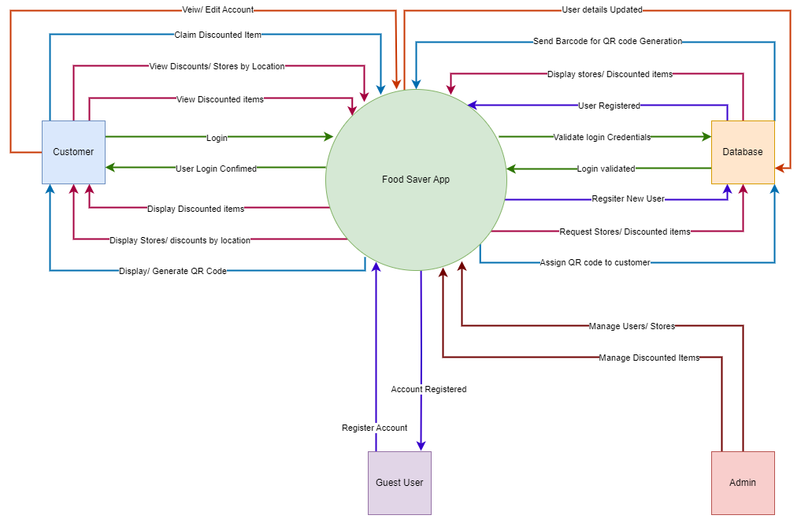

Figure 74 - Context Diagram - Iteration 2 for The Sustainable Spoonful System (Pedriquez, 2022)

The Context diagram (also known as a level 0 Data Flow Diagram) is used to represent a high-level overview of the data flow within a system (Pedriquez, 2022). It is commonly used as a reference by engineers, analysts, developers, and stakeholders as it does not require any technical knowledge to understand (Pedriquez, 2022).

### Entity Relationship Diagram – Iteration 1:

Figure 75 - Entity Relationship Diagram - Iteration 1 for The Sustainable Spoonful System (Brumm, 2022).

### Entity Relationship Diagram – Iteration 2:

Figure 76 - Entity Relationship Diagram - Iteration 2 for The Sustainable Spoonful System (Brumm, 2022).

The Entity Relationship Diagram illustrates how different entities within the system will interact with each other and is often used to design relational database models (Lucidchart, 2023)

### Data Flow Diagram – Iteration 1:

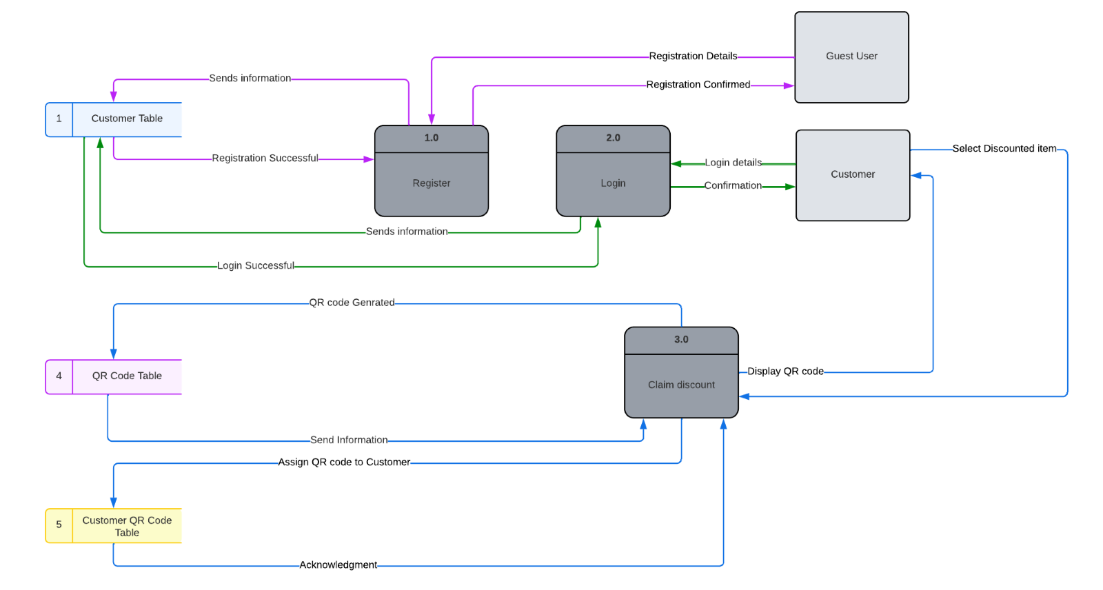

Figure 77 - Data Flow Diagram - Iteration 1 for The Sustainable Spoonful System (Lucidchart, 2023).

### Data Flow Diagram – Iteration 2:

Figure 78 - Data Flow Diagram - Iteration 2 for The Sustainable Spoonful System (Lucidchart, 2023).

The Data Flow Diagram is used to map out the flow of information within a system and can be used to design a new system or analyse an existing one (Lucidchart, 2023).

While the Customer_Retailer table is not mentioned here, it will simply serve as a junction table between the Customer Table and the Retailer table storing the customerID and retailerID to prevent duplications.

## 3.4.3 Iterative and Incremental Design

While we have multiple iterations of how our mobile application will function, this is an ongoing process that will constantly be improved upon during the development process and with more user feedback and testing.

Our approach was to map out the basic functionality for the first iteration and build on it as seen in the second iteration.

We have made the following improvements:

* For the Context diagram, we expanded upon the existing processes to giver a clearer scope of the data flow within the system.
* For the Entity Relationship Diagram, we determined the nature of the relationships between the tables and resolved any many-to-many relationships.
* For the Data Flow Diagram, we have added in an external entity (an Admin) to help better manage the system.

## Conclusion

In summary, we have approached the architectural design phase using multiple methods.

These methods include prototyping our design with wireframes, an interactive prototype, drawing up use-case diagrams to map out which users will interact with the system and what actions they should be able to perform, sequence diagrams to show what messages will be exchanged within the system between all the different objects and processes, context diagrams to observe how data will move within the system, entity relationship diagrams to assist in modelling the database and determining how entities within the system will interact with each other and data flow diagrams to aid in understanding the flow of information within the system.

By basing our design on such a solid foundation, we should be able to move from the design phase into the development phase efficiently.

# Bibliography

Fig.4. Cabrera, I., 2022. *What is a User Flow Diagram and How to Create One?.* [Online] Available at: https://venngage.com/blog/user-flow-diagram/[Accessed 21 May 2023].

Fig.67. Tilley, S. & Rosenblatt, H., 2017. *Systems Analysis and Design.* 11th ed. Boston: Cengage Learning.

Fig.68. Tilley, S. & Rosenblatt, H., 2017. *Systems Analysis and Design.* 11th ed. Boston: Cengage Learning.

Fig.69. Lucidchart, 2022. *UML Sequence Diagram Tutorial.* [Online] Available at: https://www.lucidchart.com/pages/uml-sequence-diagram[Accessed 22 May 2023].

Fig.70. Lucidchart, 2022. *UML Sequence Diagram Tutorial.* [Online] Available at: https://www.lucidchart.com/pages/uml-sequence-diagram[Accessed 22 May 2023].

Fig.71. Tilley, S. & Rosenblatt, H., 2017. *Systems Analysis and Design.* 11th ed. Boston: Cengage Learning.

Fig.72. Tilley, S. & Rosenblatt, H., 2017. *Systems Analysis and Design.* 11th ed. Boston: Cengage Learning.

Fig.73. Pedriquez, D., 2022. *What is a Context Diagram (and How Can You Create One)?.* [Online] Available at: https://venngage.com/blog/context-diagram/[Accessed 22 May 2023].

Fig.74. Pedriquez, D., 2022. *What is a Context Diagram (and How Can You Create One)?.* [Online] Available at: https://venngage.com/blog/context-diagram/[Accessed 22 May 2023].

Fig.75. Brumm, B., 2022. *A Guide to the Entity Relationship Diagram (ERD).* [Online] Available at: https://www.databasestar.com/entity-relationship-diagram/[Accessed 22 May 2023].

Fig.76. Brumm, B., 2022. *A Guide to the Entity Relationship Diagram (ERD).* [Online] Available at: https://www.databasestar.com/entity-relationship-diagram/[Accessed 22 May 2023].

Fig.77. Lucidchart, 2023. *What is a Data Flow Diagram.* [Online] Available at: https://www.lucidchart.com/pages/data-flow-diagram[Accessed 22 May 2023].

Fig.78. Lucidchart, 2023. *What is a Data Flow Diagram.* [Online] Available at: https://www.lucidchart.com/pages/data-flow-diagram[Accessed 22 May 2023].

Android Developers, 2023. *App security best practices.* [Online] Available at: https://developer.android.com/topic/security/best-practices[Accessed 22 May 2023].

Athuraliya, A., 2022. *Sequence Diagram Tutorial – Complete Guide with Examples | Creately*. [Online] Available at: https://creately.com/guides/sequence-diagram-tutorial/ [Accessed 23 May 2023].

Computer Hope, 2017. *What is Exception Handling?.* [Online] Available at: https://www.computerhope.com/jargon/e/exception-handling.htm[Accessed 22 May 2023].

DesignRush, 2023. *What Is User Authentication?.* [Online] Available at: https://www.designrush.com/agency/cybersecurity/trends/user-authentication[Accessed 22 May 2023].

designshack, 2023. *What Is a Wireframe & How to Design Them: A Beginner’s Guide.* [Online]   
Available at: https://designshack.net/articles/graphics/what-is-a-wireframe/  
[Accessed 22 May 2023].

draw.io, 2023. *draw.io.* [Online] Available at: https://www.drawio.com/[Accessed 22 May 2023].

Figma, 2023. *Figma.* [Online] Available at: https://www.figma.com/community/[Accessed 22 May 2023].

Greb, C., 2017. *Input validation.* [Online] Available at: https://medium.com/android-testing-daily/input-validation-7616fd010112[Accessed 19 May 2023].

IBM, 2022. *Server-side validation.* [Online] Available at: https://www.ibm.com/docs/en/mam/7.6.1?topic=validation-server-side[Accessed 22 May 2023].

IBM, 2023. *Overview of data validation.* [Online] Available at: https://www.ibm.com/docs/en/order-management?topic=application-data-validation[Accessed 22 May 2023].

Kazi, N., 2021. *Logging and remote error reporting in mobile apps.* [Online] Available at: https://blog.logrocket.com/logging-and-remote-error-reporting-in-mobile-apps/[Accessed 19 May 2023].

Loshin, P., 2022. *What is Encryption and How Does it Work?.* [Online] Available at: https://www.techtarget.com/searchsecurity/definition/encryption[Accessed 22 May 2023].

Lucidchart, 2020. *Context Diagram Software.* [Online] Available at: https://www.lucidchart.com/pages/examples/context-diagram-software#:~:text=A%20context%20diagram%2C%20also%20known,data%20within%20a%20technical%20system[Accessed 22 May 2023].

Lucidchart, 2023. *What is an Entity Relationship Diagram (ERD)?.* [Online] Available at: https://www.lucidchart.com/pages/er-diagrams[Accessed 22 May 2023].

Martin, J. A., 2019. *What is access control? A key component of data security.* [Online] Available at: https://www.csoonline.com/article/3251714/what-is-access-control-a-key-component-of-data-security.html[Accessed May 2023 2023].

McQuillan, R., 2022. *How to Create a Data Model in 9 Steps*. [Online] Available at: https://budibase.com/blog/data/how-to-create-a-data-model/ [Accessed 23 May 2023].

OWASP, 2019. *Input Validation · OWASP Cheat Sheet Series.* [Online]   
Available at: https://cheatsheetseries.owasp.org/cheatsheets/Input_Validation_Cheat_Sheet.html  
[Accessed 22 May 2023].

OWASP, 2021. *Cross Site Scripting Prevention · OWASP Cheat Sheet Series.* [Online] Available at: https://cheatsheetseries.owasp.org/cheatsheets/Cross_Site_Scripting_Prevention_Cheat_Sheet.html[Accessed 22 May 2023].

OWASP, 2023. *Improper Error Handling.* [Online] Available at: https://owasp.org/www-community/Improper_Error_Handling[Accessed 22 May 2023].

Smart, R., 2020. *Implementing Secure Storage | PSA Certified 10 Security Goals.* [Online] Available at: https://www.psacertified.org/blog/secure-storage-explained/[Accessed 22 May 2023].

Whitten, J. L. & Bentley, L. D., 2007. *Systems Analysis and Design Methods.* 7th ed. New York: McGraw-Hill.

Wrike., 2023. *What is Iterative and Incremental Development? | Wrike*. [Online] Available at: https://www.wrike.com/project-management-guide/faq/what-is-iterative-incremental-development/ [Accessed 23 May 2023].

‌